1. Number cards tool

Version | Date | Updated by | Summary of update
1.0 | 4th November 2013 | MW | Created
1.1 | 6th November 2013 | MW | Updated after initial discussion with Chris
2 | 13th Nov | MW | Following meeting with client
2.1 | 14th Nov | MW | Added roman numerals to 1.1.7.3  Clarified clear all cards in 1.1.6.3
2.2 | 18th nov | MW | Added note on how to deal with stack sizes which are greater than the number of cards in a "type" - 1.1.73  Added "Show all values to 1.1.5.2"  Updated 1.1.3.3 to clarify text resize.
2.3 | 18th nov | MW | Updated screenshots now show "Show all values" button.
2.4 | 27th nov | MW | Screenshots updated
2.5 | 16 dec | MW | Minor updates to custom numbers section in 1.1.7.3

1 Description of the tool

Number cards

I can open the tool in its default state
Figure 1 Number cards in default state
There is a stack of draggable cards bottom left of the screen.
There is a bin bottom right of the screen.
There is a large container area which takes up the majority of the screen - the cards are dragged into this area.
There is a button titled "Hide all values" near the bottom of the screen. (see later section for details)
There is a button titled "Show all values" near the bottom of the screen. (see later section for details)
There is a button titled "Clear all cards" near the bin. Clicking this removes all cards currently in the container.

I can drag cards into the main part of the screen
I can click on the “stack” of cards lower left, and drag a card onto the screen (see Fig 2).
By default, the cards are numbered, counting in 1s. The first card I drag is “1”, the second card I drag is “2”, and the card now at the top of the stack is “3” (see Fig 2).
Figure 2 cards dragged on screen
The card can be dropped anywhere in the container. There is no need for cards to "snap" to any position.
The user can overlap cards if they wish.
1.1.2.1 When all cards have been dealt, the stack is used up and disappears. If the user wants to add further cards they would need to go to the set up menu.

I can edit the labels on the cards

1.1.3.1 This is achieved by clicking on the existing label.
To clarify, if i click anywhere around the current label, the current text is highlighted. If I type, a typing cursor appears and I can type in the card. The hit area here should be generous but not interfere with the ability to flip the cards (discussed later in document).
1.1.3.2 The card will accept a maximum of 5 characters.
1.1.3.3 There is a default font size used. As the user adds more character the font may have to decrease to fit the characters. For example, default font size should fit 2 characters without problem. If user enters 3 or 4 characters font size may have to drop to a slightly smaller size. If user enters 5 characters, font size may have to drop slightly again.
If the font size needs to be smaller, it should update after the user finishes typing. It could be that when the user is typing they see the smallest font size and after they type it resizes to get larger, if there is space.
1.1.3.4 If I click the mouse elsewhere on screen, my typing ends.
Figure 3 different font sizes

I can reposition the cards by clicking and dragging
Figure 4 cards repositioned
I can drag the cards to another position on the screen. I can touch anywhere on the card to drag it, even the areas of the card which allow me to edit or flip when clicked. The tool knows the difference between a click and a drag. So, if I click on the middle of a card, I can edit the card. If i click and drag from the same spot, I will not edit the card, it will just drag.

I can flip the cards over
Each card has a flip icon in the bottom right of the card:
If I click this area of the card, it flips to show the other side of the card:
I can click the flip icon as often as I want to flip the card back and forth between these two states.
The hit area around this button needs to be fairly generous, so that it isn't too difficult to click.
1.1.5.1 Hide all values
There is a button called "Hide all values".
This button is greyed out if
a) there are no cards on screen
b) all cards on screen are currently "hidden", i.e. they are showing the question mark side of the card
At any other time the button is active.
If I press "Hide all values", all cards must show the question mark state. Any cards not showing the question mark, immediately flip. Any cards which are already showing the question mark side remain that way. So, this control is not a "flip all" control, it is a way of making all cards on screen show the question mark.
After "Hide all values" is pressed the button greys out because all cards are now hidden. As soon as any card becomes "unhidden" the button is active again.
Figure 5 all values "hidden"
1.1.5.2 Show all values
There is a button called "Show all values".
This button is greyed out if
a) there are no cards on screen
b) all cards on screen are currently "showing", i.e. there are no question marks
At any other time the button is active.
If I press "SHow all values", all cards must show their value. Any cards showing the question mark, immediately flip. Any cards which are already showing the value remain that way. So, this control is not a "flip all" control, it is a way of making all cards on screen show the value.
After "Show all values" is pressed the button greys out because all cards are now hidden. As soon as any card becomes "hidden" the button is active again.
NOTE: it is possible for "hide all values" and "Show all values" to be active at the same time (if some cards are hidden and some are not)

I can delete cards by dragging them to the bin
This action cannot be undone.
The bin should highlight when an item is hovered over it.
Figure 5b: card dragged over the bin makes bin highlight (it has gone darker in this screenshot)

Clear all cards
There is a button called "Clear all cards" beside the bin. Clicking this button removes all cards currently within the container (not cards in the stack)
This button is greyed out if there are no cards in the container.
Note that there is a difference between Clear All Cards and Reset. Both will remove all the cards that are in the main container. But, unlike Reset, Clear All Cards does not reset any user settings made to the stack. For example, If I have set the stack to deal red prime numbers, it will still do that after I click Clear All Cards. But if I Reset, the stack goes back to it's default behaviour.

I can click set up to open a menu where I can configure the tool
The Set up menu appears on a repositionable window. Set up menu design will be provided.
Clicking the OK button on the Set up window saves and applies any changes I have made.
Clicking Cancel on the set up menu closes the window without applying or saving changes.

Generating a new stack
Note that every time I go in to set up and press OK, a new stack is generated. This new stack takes on the properties currently selected in set up. It is possible to open set up, change no properties, click OK and see a new stack. In this case the stack would take on the default properties.
Example: i have a 1-20 stack. I drag out cards 1, 2, 3, 4. The top card in the stack is now 5. I go to set up and click OK. When I return to the main screen cards 1, 2, 3 and 4 are still on the main container. However, the top card in the stack is now 1. This is because a fresh stack has been generated by user entering set up and clicking OK.

In set up I can choose the number of cards in the stack

Options in the drop-down menu are 5, 10, 20, 40. (20 is the default selection)
If the user enters set up and presses OK, they immediately generate a new stack of cards with the selected properties.

In set up I can choose the type of numbers
The available Types of Numbers in the drop-down are:
- Serial – the cards are labelled 1,2,3,4,…
- Odds – the cards are labelled 1,3,5,…
- Evens – the cards are labelled 2,4,6,…
- Triangles – the cards are labelled 1, 3, 6, 10, 15, 21… (you cand find the first 40 here: http://www.mathematische-basteleien.de/triangularnumber.htm)
- Squares – the cards are labelled 1, 4, 9, 16,… (they are squares of 1, 2, 3,..)
- Primes - – the cards are labelled 2, 3, 5, 6.. (the series of prime numbers)
- NEW Roman numerals (to 20) - the cards are labelled I, II, III, IV, V, VI, VII, VIII, IX, X, XI, XII, XIII, XIV, XV, XVI, XVII, XVIII, XIX, XX
- Random (0-99) – each card is labelled with a random 2-digit number
- Random (0-9) - each card is labelled with a random 1-digit number
- NEW - 1-6 dots, like a 6-sided die: 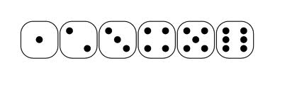
- NEW - 1-9 dots, with dots laid out as on playing cards:
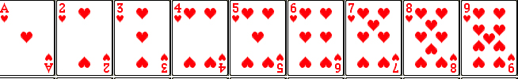 (we don't want to show numbers or hearts as in this screen shot, we just want dots to be laid out in the same format as shown here)
- Custom – when this type is selected, it activates two input boxes called “first value” and “increment” at the bottom of the set up menu. The user puts a number into each of these fields (default is "1" in each field). They can enter whole numbers, negative numbers or decimals .
  - The first value box will accept a maximum of 4 characters but whole numbers should not exceed 1000, so the user can enter 1-1000 or decimal/negative numbers which are up to 4 chars: -999 or 9.999 or 12.3.
  - The increment box will accept a maximum of 3 characters
  - It should not be possible to enter more than the stated number characters - after 4 (or 3 for increment) characters are entered the user would not be able to type any more.
- Examples of first numbers and increments:
  - First value = 0 and increment = 2 deals 0,2,4,6,… (the 2x table)
  - First value = 9999 and increment = 10 deals 9999, 10009….
  - First value = 10 and increment -10 deals 10, 0, -10….
  - First value = 0.1 and increment = 1 deals 0.1, 1.1, 2.1….
  - Note on decimals: the decimal point should be medial on the card itself (it should be in the centre, not at the bottom), e.g.
It may not be possible to show the decimal point as medial when the user is actually typing the text itself - this is OK but it must show as medial on cards generated using custom method and on cards which have been edited to use a full stop (any full stop is positioned centrally as shown).
NOTE: the "first value" and "increment" text entry boxes should be greyed out UNLESS "Custom" is selected in the "Type of Numbers" drop-down. There is no point adding values to these boxes unless Custom is selected.

NOTE ON STACK SIZE: for some types of numbers (roman numerals, dots) the range of numbers that can be generated is less than the amount of cards in some stacks. For example, I could choose a stack size of 40 but if I choose roman numerals as my type of number, there are only 20 cards. In this case, the stack should simply repeat. So, when the full range of cards have been used, the next card in the stack would be the first card again (e.g. the roman numeral for 1, or the "1 dot" card if you chose dots type).
The Types of Numbers can be altered without affecting the labels of any cards already on the main screen. For example, I can set Types of Numbers = odds and deal cards labelled 1, 3, and 5. Then I can change to Types of Numbers = Evens and deal 2, 4, and 6. That is, the new Types of Numbers property does not apply to cards already dealt onto the main part of the screen, only to those left in the stack. The Types of Numbers can be changed several times, resulting in a set of cards like those shown in Fig 6.

I can set the default colour of a card from a palette of 6 colours
A palette appears when I click the Default card colour control. Fig 6 shows the results of colouring a card. Palette colours will be provided as part of set up menu design.
The default card colour affects only cards in the stack. Any cards currently in the main container do not change colour.
Example: I enter set up and set card colour as red and number of cards as 20. I click OK and return to the tool. I drag out cards 1, 2 and 3. They are red. I now go back to set up and change colour to blue. I click OK to go back to the main screen. I can still see the 1, 2, 3 cards in red in the main container. In the stack, the stack has refreshed to show number 1 again and the card is blue. I drag 1, 2, 3 again. I now have a 1,2,3 in blue as well as a 1,2,3 in red.
Fig 6 - a set of cards with various properties set in the Set up menu.

I can set cards in the stack to be hidden as default
There is a checkbox titled "Card values hidden as default". If I tick this, the cards in the stack will all display the question mark side of the card. When dragged onto the main container, they continue to show the question mark, until such times as I flip that card.
This setting does not affect cards already in the container.
If a card is coloured, that colour can be seen whether the card is flipped or not:

I can click the “i” button to see a help text
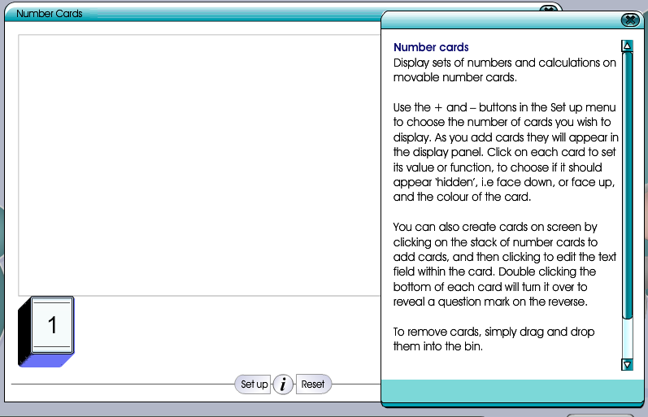
Figure 89 Number cards "i" text (SCREENSHOT FROM OLD VERSION OF TOOL)

The Help pop-up can be repositioned on the screen by dragging from the title bar of the pop-up

The text to display will be provided.

I can click Reset to reset the tool to its default state
The tool returns to its default state.
When Reset is clicked, there should be a pop-up asking the user to confirm they want to reset, to prevent losing their set values because of an accidental click on the button. The pop-up would say
Are you sure?
Clicking Reset means that any changes you have made will be lost. Is that OK?
Yes - Reset No - keep my changes

2 Artwork requirements
No artwork required.

